Introduction of the raw data:

* Table 1:

Company U Time Entry Record(Time record for Company U, 2858 record), detail of the column

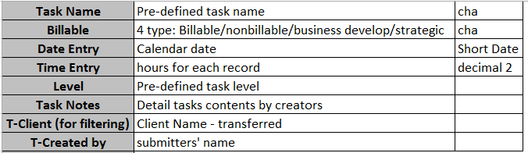

* **Table 2**

Name: USMWorkschedule(Working calendar for Company U)

Supplementary information for the work schedule.

I have an idea when we present our group work in class. We can make it as a real ‘meeting’ to review the dashboard and gradually expand the dashboards to deep dive the details.

Dashboard Screenshot

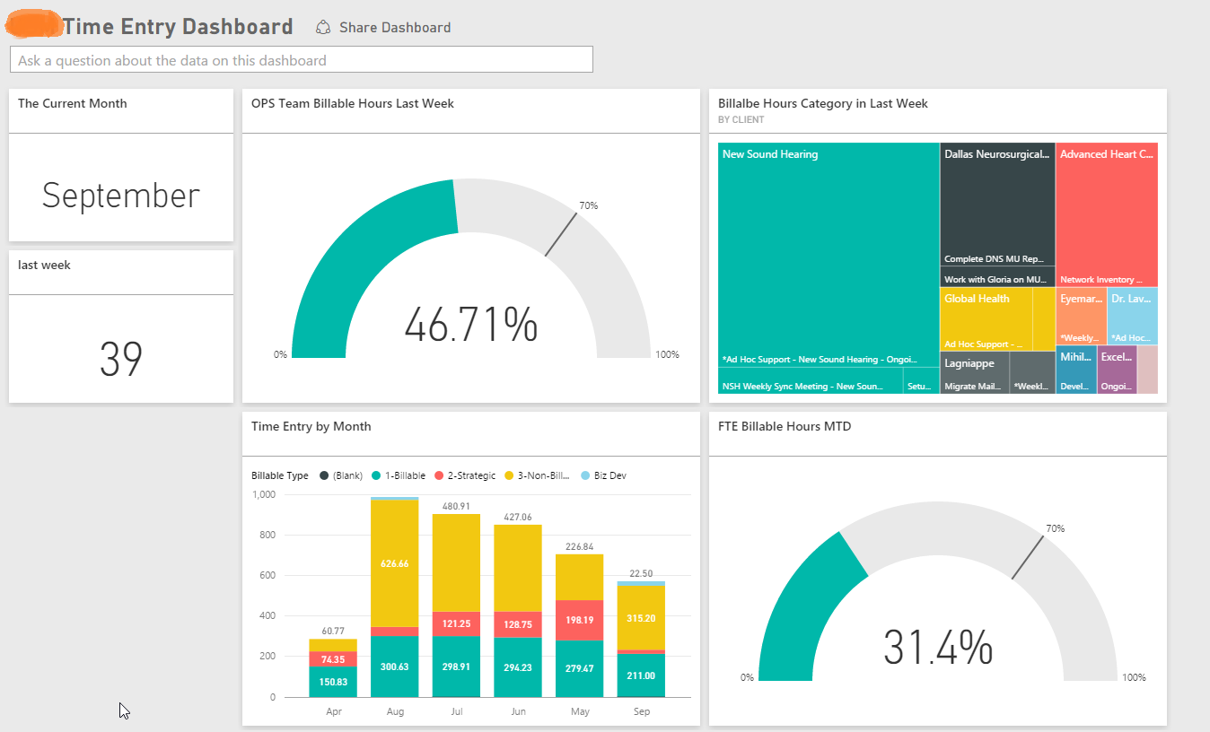

Charts

Overall Team View

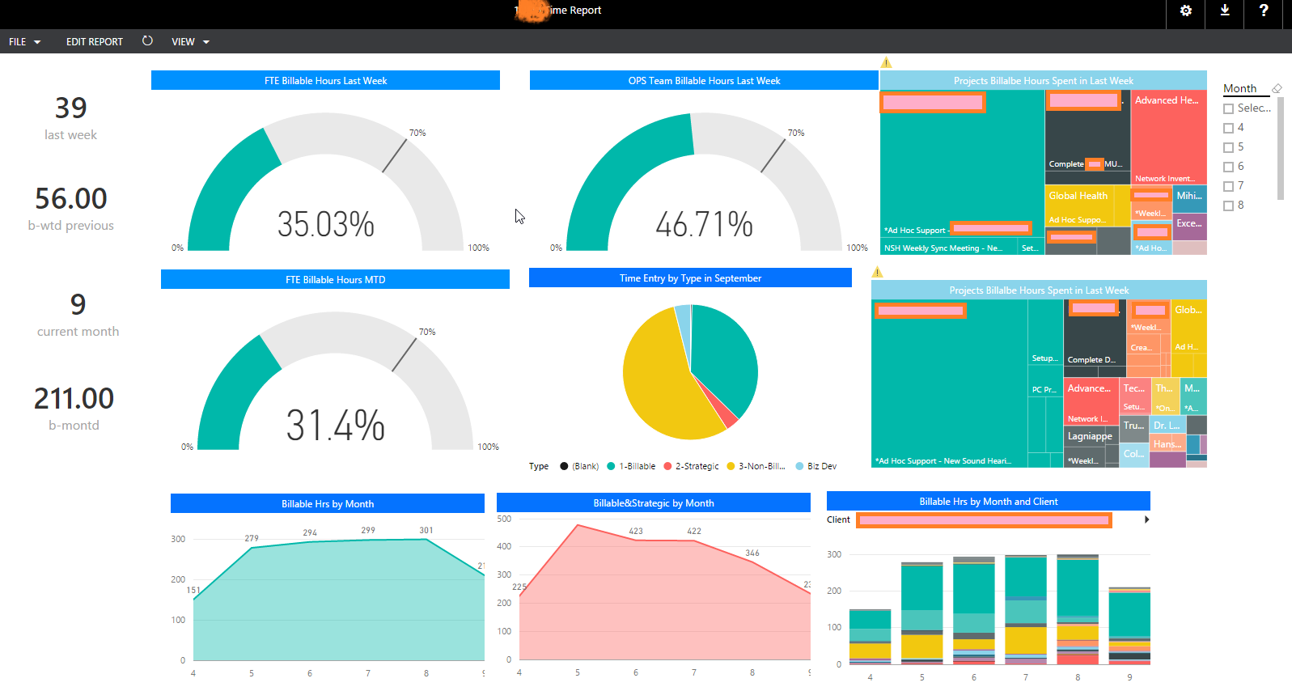

Personal View

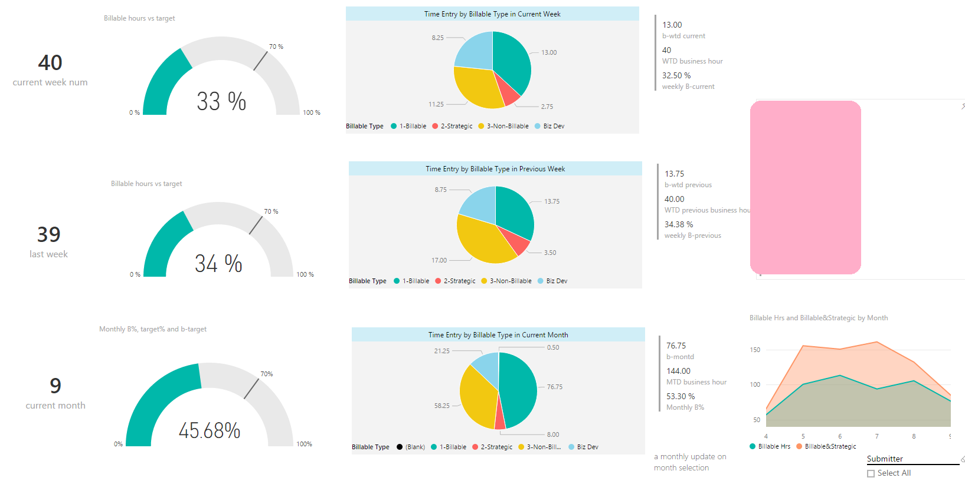

OPS Team View

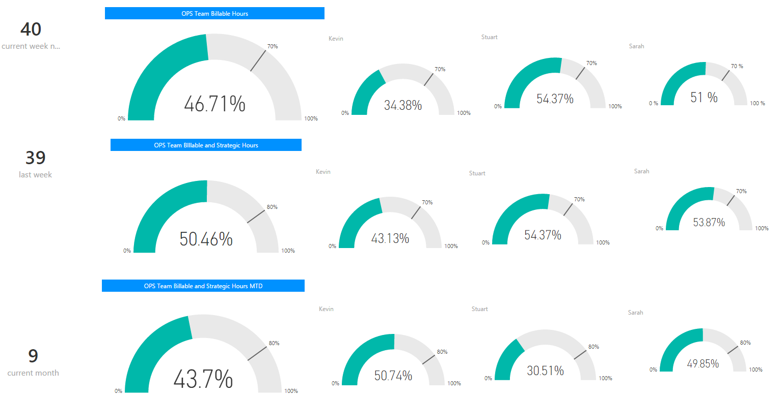

High Risk Task View

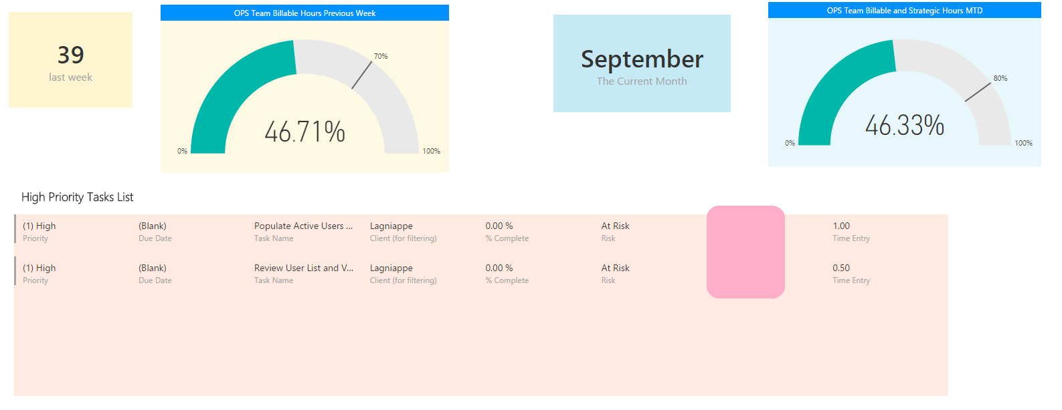

Long-term project overview

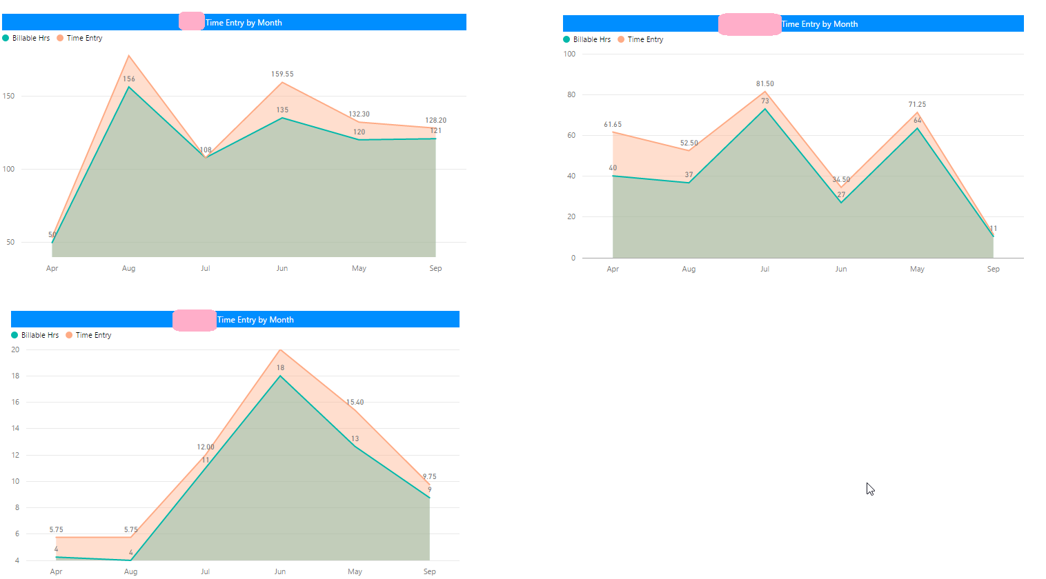

One-time project

